A000-AM,C-Taino-Axe, Monolithic, with Handle-Ceremonial-Serpentine-1000 CE

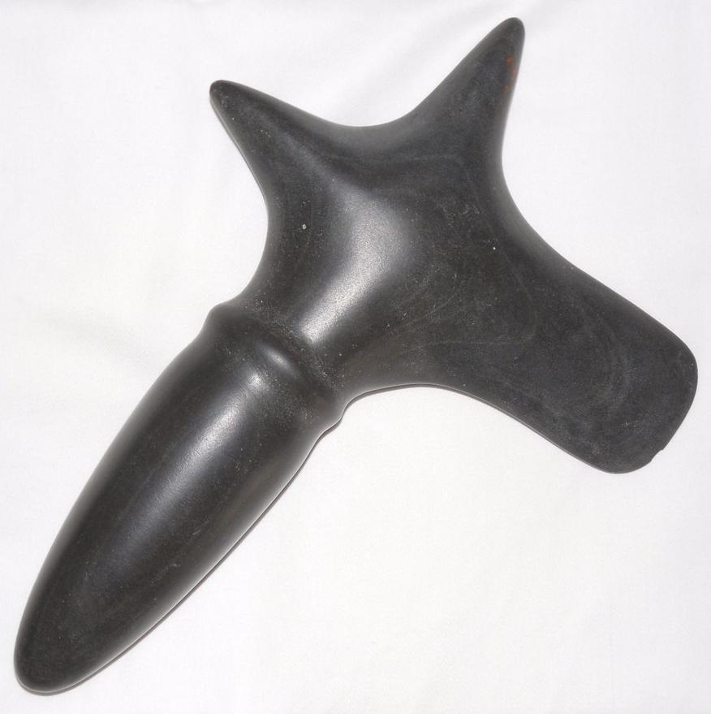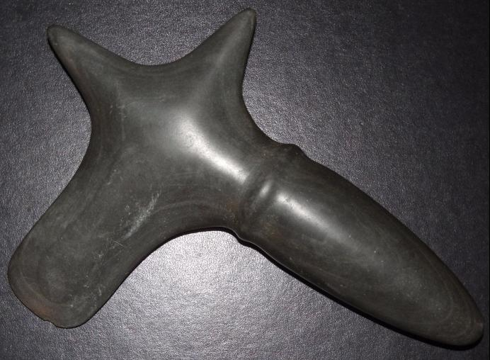

Fig. 1. AM,C-Taino-Axe, Monolithic, with Handle-Ceremonial-Serpentine-1000 CE

**Case No.: 18**

**Accession No.**

**Formal Label:** AM,C-Taino-Axe, Monolithic, with Handle-Ceremonial-Serpentine-1000 CE

**Display Description:**

This ceremonial serpentine monolithic axe is a rare baton used by Caciques to symbolize their power and authority as it originates with the Sun or Great Spirit (the upward point of the axe) to the Cacique (the handle) to the people (the horizontal point and blade of the axe).

This axe has the same provenience as highly polished celts ceremonial celts of a petuloid shape without an attached figure of local metamorphic stone. They may have mythic significance as a celt was used to free mother tortoise, the progenitor of Mankind. They were also used for ceremonial purposes, as none have marks of use-wear. The distribution of highly polished celts extends from the Bahamas to Trinidad, suggesting a sophisticated system of trade and exchange of élite ceremonial objects among caciques in efforts to establish alliances or exchange of such objects as means of currency (Roberts 2014: 163).

**LC Classification: F 1909**

**Date or Time Horizon: 1000 CE**

**Geographical Area:** From the Dominican Republic, i.e., Eastern Hispaniola

**Map:**

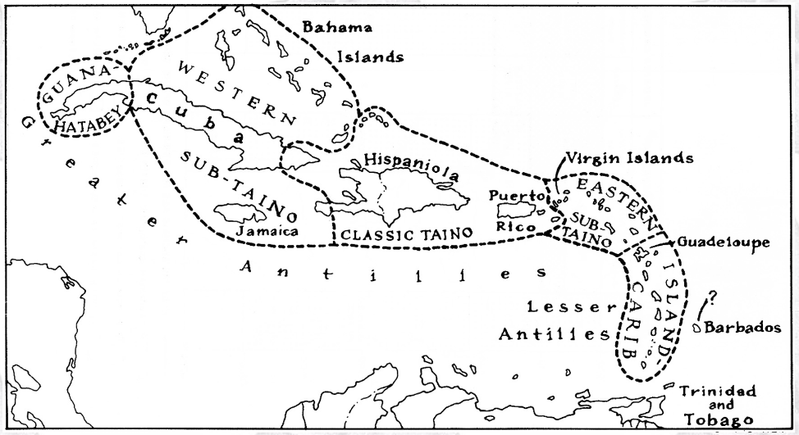

**Caribbean c 1500 after http://www.latinamericanstudies.org/maps/Ciboney-Taino-Carib-**

**GPS coordinates:**

**Cultural Affiliation: Classic Taino**

**Medium: serpentine**

**Dimensions: L 9 in**

**Weight:**

**Condition: original**

**Provenance:** From the Dominican Republic, i.e., Eastern Hispaniola

**Discussion:**

**References:**

Roberts, Larry. 2014. *Taino Sculpture: art of the gods* (Micanopy, Florida: Signature Book Printing)